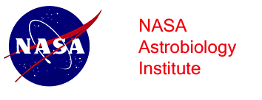 | NASA Astrobiology  Early Career Collaboration Award

Applicant Information
Applicant Name:
 | Last | First

Title of Proposal
Career Stage |  | Email
(Undergraduate, Graduate or Ph.D. student,
Postdoc, Faculty)

Applicant Mailing Address:
 | Street Address | Apartment/Unit #

 | City | State | ZIP Code

Current Institution
Name: |  |  |  |  |  | City, State:

Department:

Advisor or Supervisor
From: |  |  | To:

Collaboration Plan
- Please attach a brief description of the research you plan to conduct at the hosting laboratory (include, for example, any technique you expect to learn, or equipment you will need to use) and how the collaboration is relevant to your research, as well as a rationale for the team(s) and researchers you plan to visit and a short (2 - 3 pages or less) statement explaining your research background, interest in astrobiology and career plan.

Budget and Schedule
- Attach a budget breakdown describing what funds are required, how they will be used and the approximate dates of travel

Letters of Recommendation
Either attach letters of recommendation from your academic supervisor (advisor, supervisor or department chair) and from the researcher(s) you plan to visit, or have them send letters directly to Melissa Kirven at the email address below, indicating support for this collaboration.

Please email this completed application and attachments to Melissa.kirven@nasa.gov
Application Deadline: April 1, 2020

